SCons Build Automation
TL;DR
Use SCons in the Git repository to automatically build, isolate modules in firmware, and generate a DBC header file.

Problem
Since we are using a single project for multiple ECUs with different functionality, we will encounter conflicts.
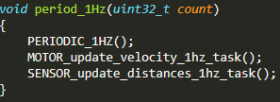
In foxp2/L5_application/periodic_scheduler/period_callbacks.cpp
In the snippet above, the motor team may want to add a function call to the 1 Hz context to update motor velocity, but the sensor team may also want to update distances in the same 1 Hz context.
The problem is that an ECU responsible for motors does not have access to sensor peripherals; meanwhile, the sensor ECU does not have access to motors.

Approach
To resolve the problem, we should be using MACROS or feature flags to isolate and disable tasks primarily by removing function calls from the compiled firmware.
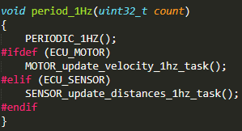
In foxp2/L5_application/periodic_scheduler/period_callbacks.cpp
In addition, we should add one more layer of abstraction instead of the approach above.
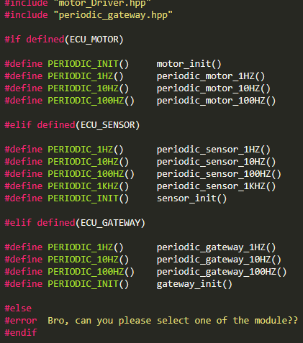
In foxp2/L5_application/FOXP2/Periodic_Dispatcher.hpp
Compiled firmware in foxp2/build/motor/foxp2_motor.hex
Compiled firmware in foxp2/build/sensor/foxp2_sensor.hex
We also need to specify the name of the ECU for the DBC parser Python script to generate the DBC represented header file. This step needs to be done before compilation.
> python dbc_parse.py -i 243.dbc -s {NODE_NAME} > generated_dbc.h
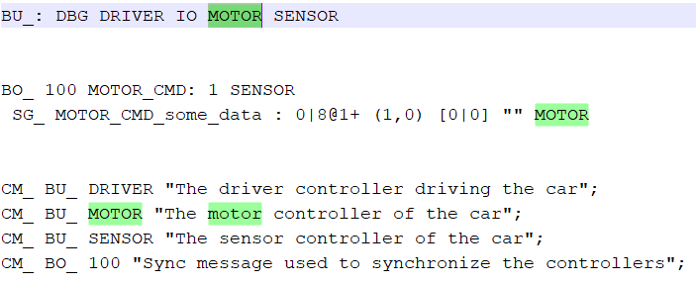

Proposed Solution
SCons, a C builder tool (like Make but more awesome), is now integrated to the foxp2 Git repository.
Foxp2: https://gitlab.com/foxp2/foxp2

To build firmware, navigate to the repository foxp2 directory and invoke SCons.
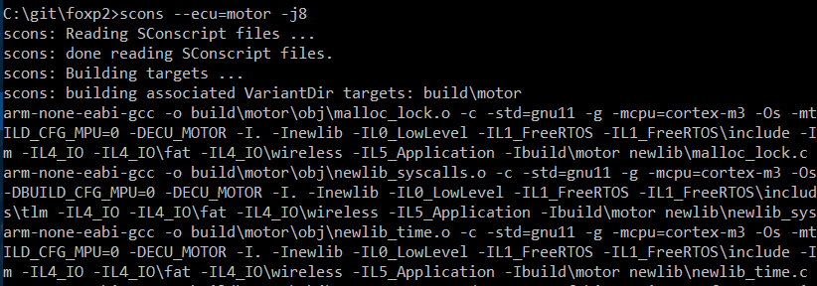
In the example, SCons will do the following:
- Build firmware and store it in foxp2/build/motor
- Invoke the DBC parser and store the generated header in foxp2/build/motor
In the example, the flag --ecu=motor will do the following:
- Define ECU_MOTOR in firmware
- Define DBC node as MOTOR
The flag -j<n> allows you to build firmware using multiple CPU cores.

A successful build will produce artifacts in a newly created build directory.
Compiled firmware in foxp2/build/motor/foxp2_motor.hex

Setup – Linux
SCons
ARM toolchain
Setup - Windows
Download SCons
- http://scons.org/
Download ARM GCC
- https://developer.arm.com/open-source/gnu-toolchain/gnu-rm/downloads
SCons also needs a path to the ARM toolchain
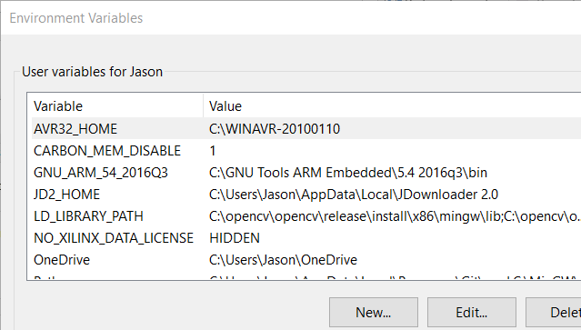
Environment variable for Windows
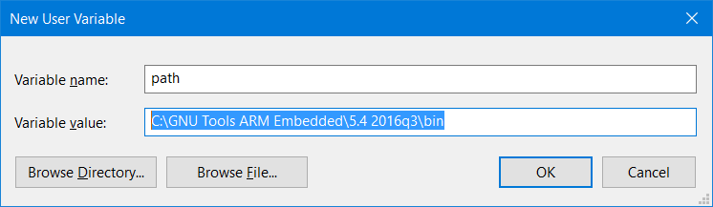
Setting up the environment variable path in Windows

You can download a new copy of the ARM toolchain
- C:\GNU Tools ARM Embedded\5.4 2016q3\bin
Or you can steal Preet’s copy of the ARM toolchain from the SJSU_Dev package
- C:\SJSU_Dev\toolchain\bin

